**Heatmaps and Highlight Table**

The highlight table below shows profits by *Region*, *Sub-Category*, and *Segment* for the Superstore dataset using a diverging palette, a colour scheme that is designed to highlight a distinct midpoint or central value while showcasing two contrasting or opposing extremes on either side.

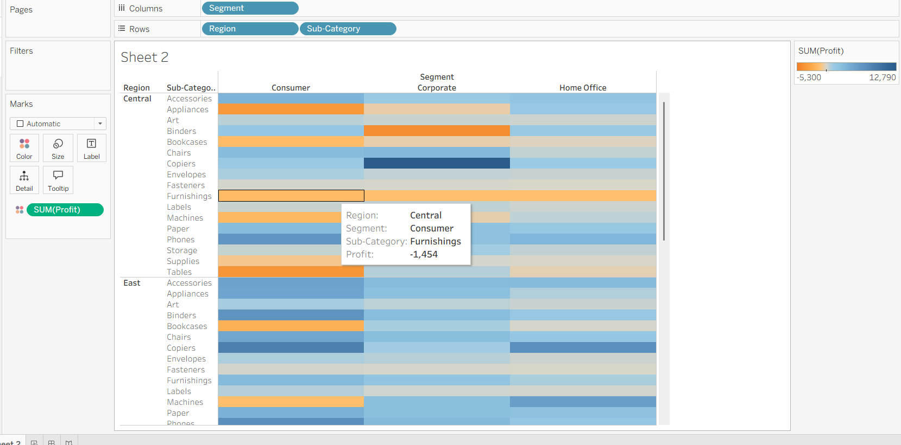

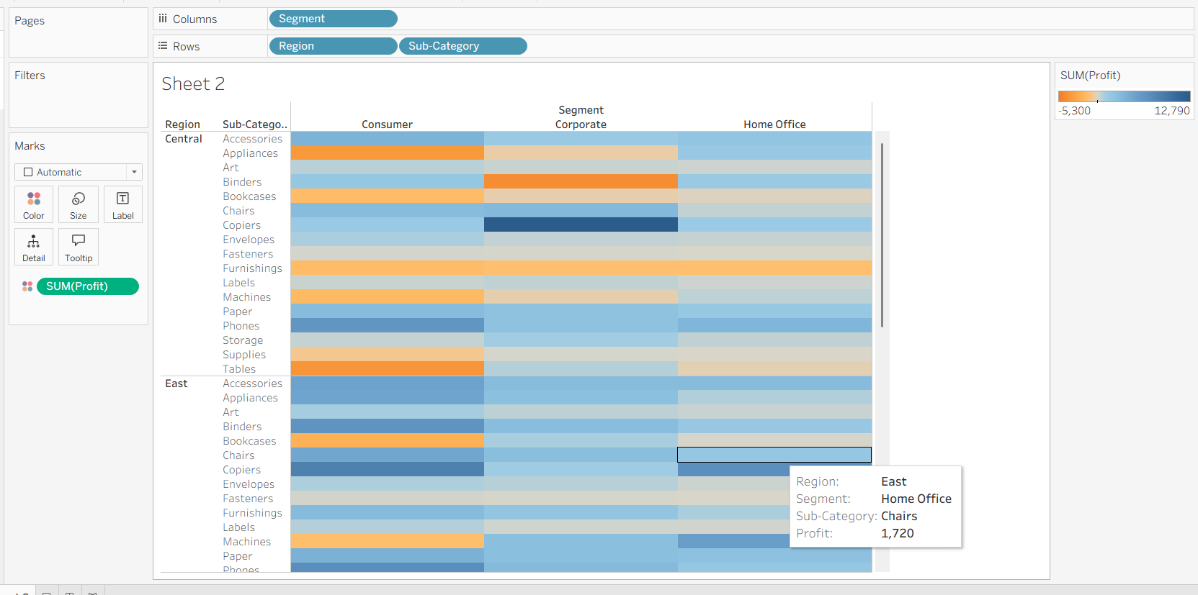

The heat map below shows profits and sales by *Region*, *Sub-Category*, and *Segment* for the Superstore dataset. Notice that in the highlight table above, profits are indicated by color. In the heat map below, while profits are indicated via color, sales are additionally indicated by the size of the markers in the table.

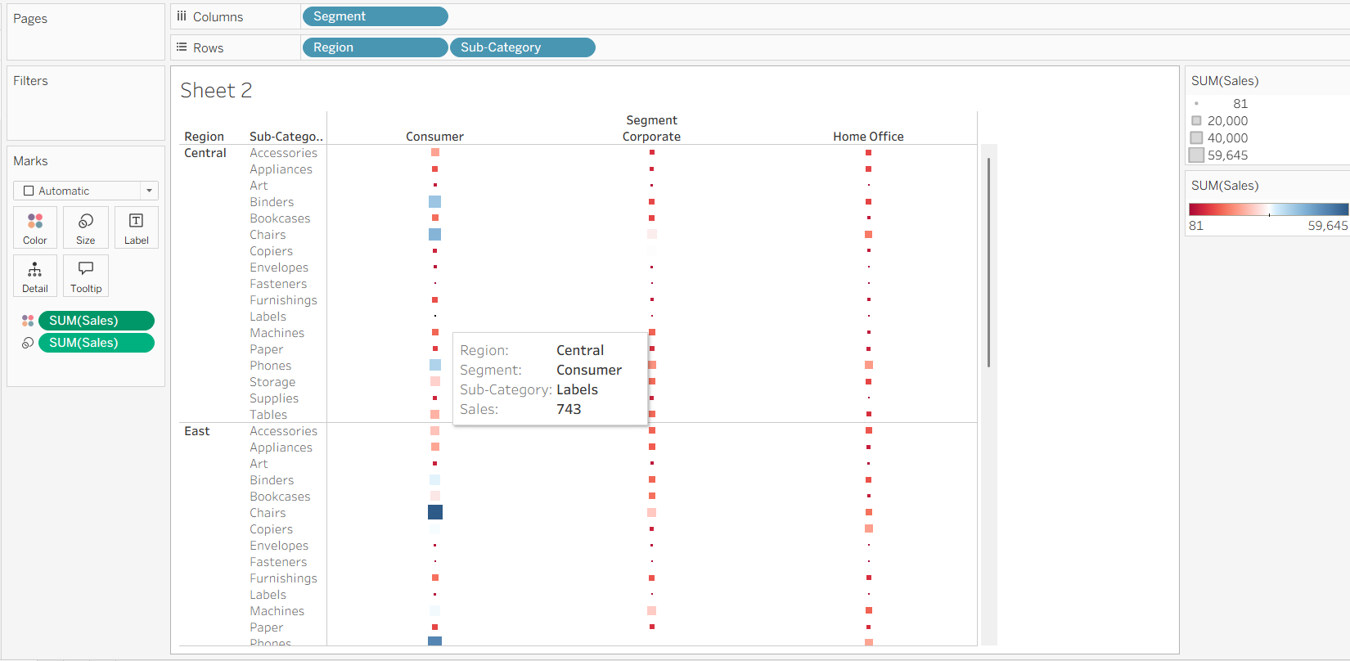

Now we want to look at the overall sales trends over the course of the year. You build a table that has *DAY(Order_Date)* in the Rows shelf and *MONTH(Order Date)* in the Columns shelf. Every cell within the table represents a day out of the year. Then, I added the *Sales* measure to the table to explore trends in sales.

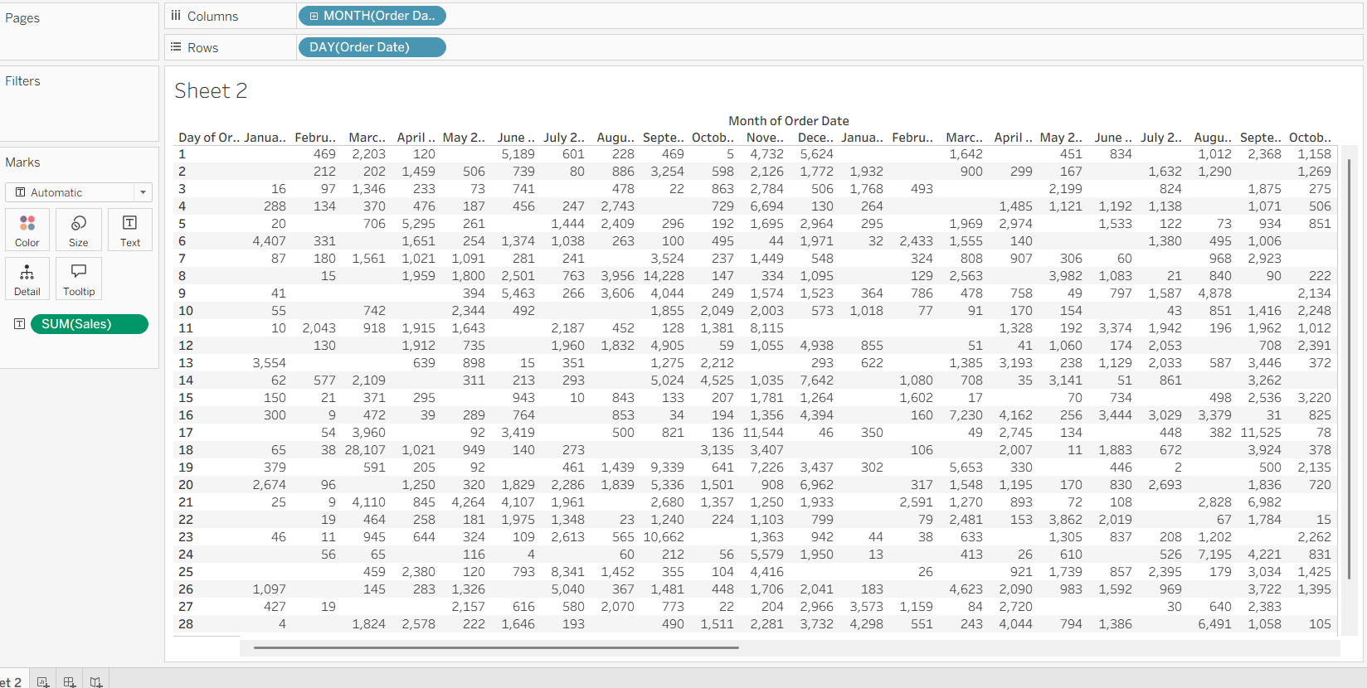

Now I realize it's incredibly challenging to find useful information buried within these rows and columns of numbers with regards to sales trends. Which days had the highest sales? Which months tended to have lower daily sales? The information is certainly there — it's just harder to pull insights from all that data. However, look at what happens when you change the mark used to describe *SUM(Sales)* from Text to Color, creating a highlight table:

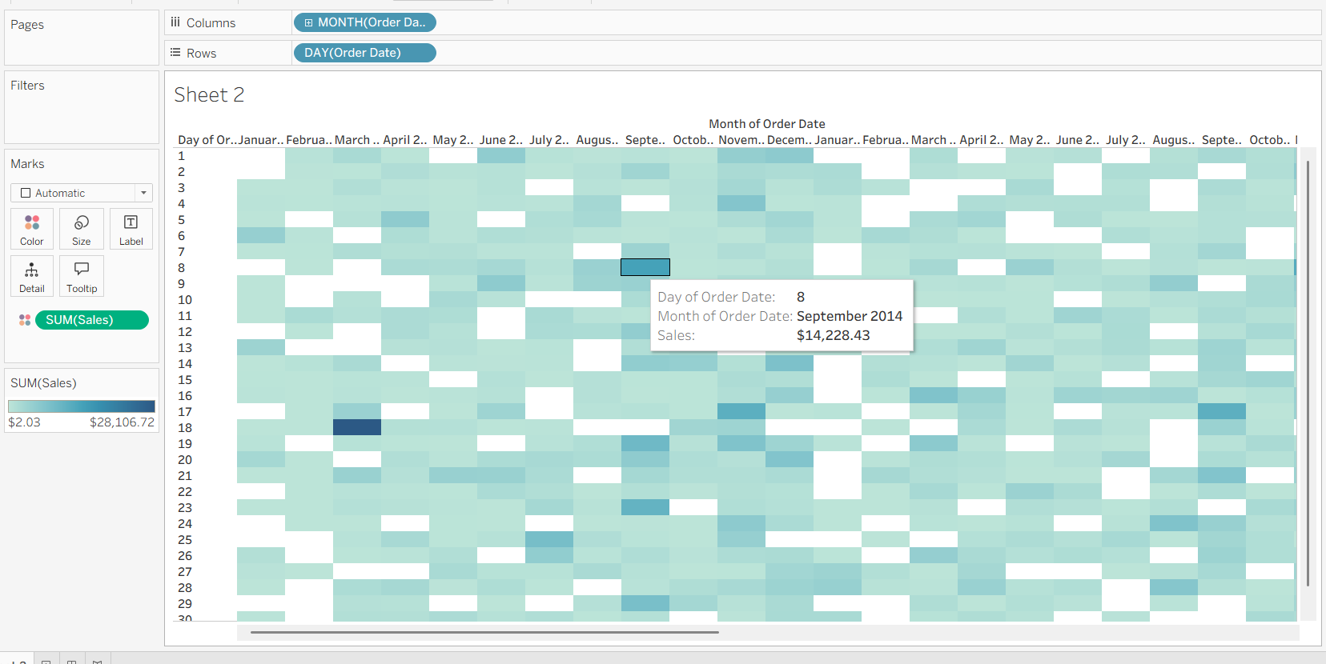

Now we can easily answer which days had the highest sales? Which months tended to have lower sales? We can notice how November and December are darker, indicating there were more sales in those months.

**Highlight Table :**

A highlight table allows you to visualize trends you wouldn't otherwise be able to easily see within a text table.

To take this a step further, using both size and color, you could make this a heat map. You can drag *Sales* to the Size property, and each entry will change to a square.

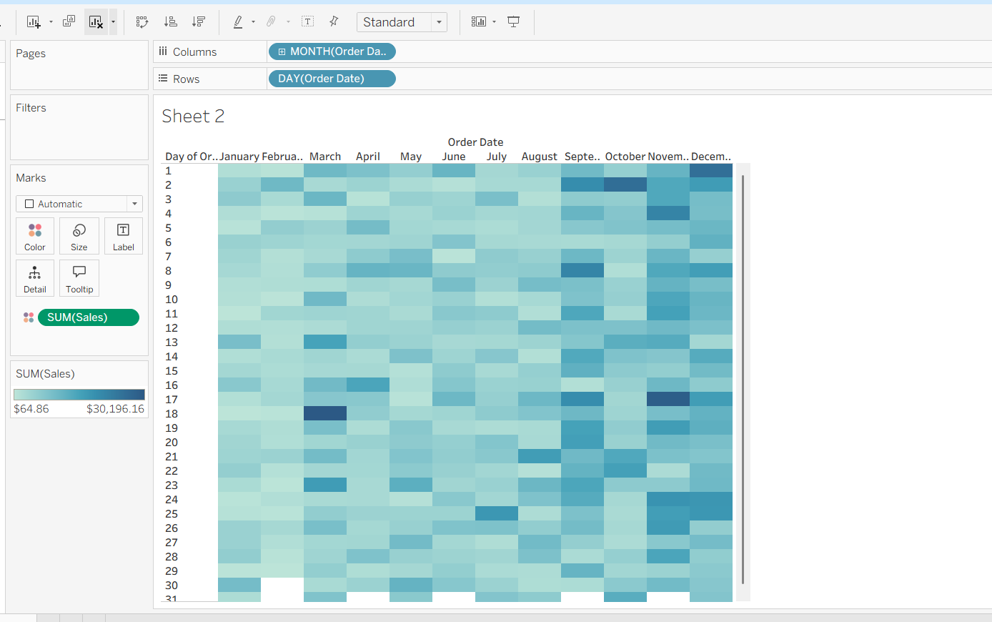

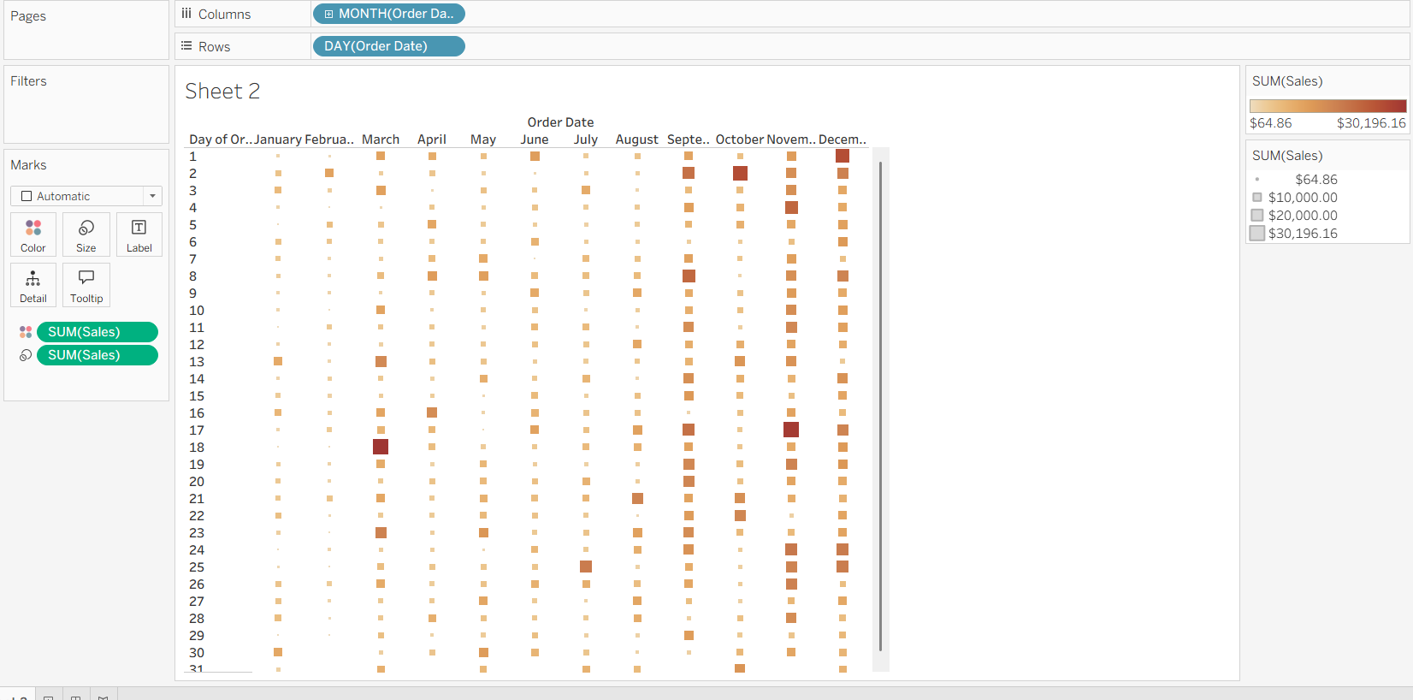

Below visual is the comparison of sales data for the Region monthly

